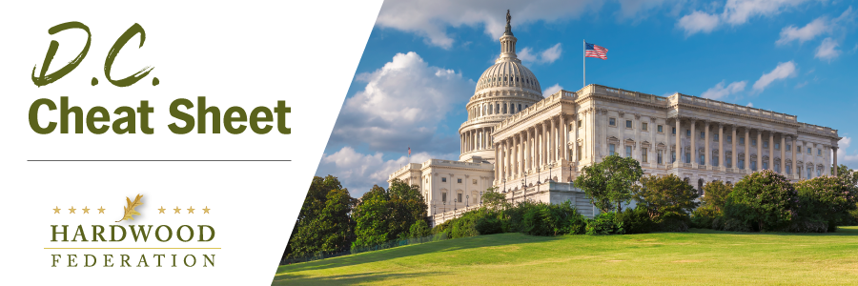
Quick Updates from Your HF Team

Hardwood Industry, Allies Take Air Quality Argument to White House
On Wednesday, October 25, the Hardwood Federation joined the U.S. Chamber of Commerce, National Association of Manufacturers (NAM), the American Public Power Association, and ten other industry groups in a meeting with the White House Office of Management and Budget (OMB) to advocate against EPA’s proposal to tighten the air quality standard for fine particulate matter (PM 2.5), currently set at 12 micrograms (ug) per cubic meter to an anticipated level of 9 ug. Lowering the standard would place 589 counties in non-attainment and hundreds more on the cusp of non-attainment, exposing industry to new regulations. To view a map showing potential nonattainment counties in red, and borderline counties in pink, click here. As a point of reference, the European Union standard is 25 ug. OMB is currently undertaking a stakeholder review before releasing a final standard. While compliance currently falls mainly on the backs of “major sources” of pollution under the Clean Air Act such as power plants and chemical refineries, the Federation is concerned that lowering the standard would capture currently unregulated hardwood mills and manufacturing facilities operating on the cusp of or within newly designated non-attainment areas, triggering costly analysis and monitoring in the event a plant seeks to expand operations. According to a study conducted by the American Forest & Paper Association and American Wood Council, the wood products sector could take on up to $900 million in compliance costs if the agency imposes a standard of 9 ug, a level on which EPA accepted comments. The Federation will keep you posted on next steps related to EPA’s action.
Manufacturers Release Study Showing Gargantuan Cost of Regulations
Although EPA burdens on the manufacturing sector have moved to the front burner this fall, according to a new study by NAM, air quality rules are only the tip of the iceberg. In 2022, according to NAM, the total cost of complying with federal rules and regulations reached over $3 trillion, which equals 12% of U.S. GDP. As that relates to small manufacturers such as sawmills, the cost translates to $50,100 per employee. Stay tuned for more details related to this study and other tools as the Federation pushes back on growing regulatory initiatives from the Administration as it enters the final stretch of its current term.
Take Four! House Taps New Speaker
On Wednesday afternoon, the House brought the drawn-out process of choosing a new Speaker to a close by voting for Rep. Steve Johnson (R-LA), by a vote of 220 to 209. A united GOP caucus finally passed the 217-vote threshold needed to push a new speakership across the finish line. This follows a chaotic week in which Speaker Johnson’s nomination followed in the wake of the withdrawal of Rep. Tom Emmer (R-MN), whose candidacy lasted less than 24 hours. Now that the House is free to roll up its sleeves on the farm bill and budget matters, the Federation will keep you posted on the House agenda as it unfolds.

