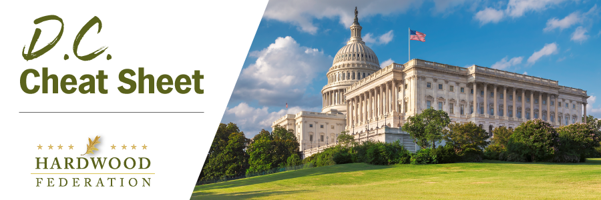

Quick Updates from Your HF Team

Hardwood Industry Argues Management Essential for “Climate Resilient Forests”
On July 18, the Hardwood Federation filed comments with USFS, urging federal regulators to emphasize active forest management while considering policies that will strengthen U.S. forests, pursuant to an Advance Notice of Proposed Rulemaking (ANPRM) published in April. Industry also urged the agency to use existing authorities and focus on the forest planning process as the primary tool for advancing its objectives before moving forward with new regulatory requirements. Although the timeline for next steps is uncertain, USFS may issue a proposed rule soliciting comment on a narrower suite of issues to more narrowly define policies that promote resilient forests.
Business Community Aligns with Hardwood Industry on ESA Expansion
On July 24, the U.S. Chamber of Commerce conducted a coalition meeting to review environmental policy challenges facing the business community and spotlighted recent proposals by the Administration to expand the scope of the Endangered Species Act (ESA). The coalition focused on two specific initiatives being addressed by the Federation: the USFWS proposal to ban consideration of economic impacts when reviewing ESA designations; and reinstatement of a “blanket rule,” which extends almost identical control measures to species classified as “endangered” as those listed as “threatened.” The Federation is drafting comments on the Administration’s proposals, which are due August 21.
House to Take Up NLEB “Resolution of Disapproval”
The House is expected soon to take up S.J. Res. 24, a “Resolution of Disapproval” that would rescind the Administration’s November classification of the Northern Long-Eared Bat (NLEB) as “endangered,” as opposed to “threatened.” In May, the Senate narrowly approved the measure by a vote of 51-49. Although the House is expected to pass the resolution, the President has stated that he would veto the measure, doubling down on his Administration’s policies.

