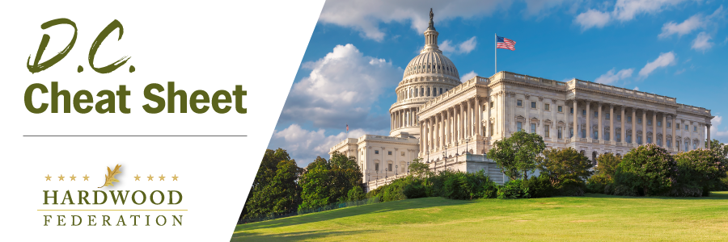
Quick Updates from Your HF Team

Mark Your Calendar Today! The Hardwood Federation has scheduled Fly-In 2024 for Tuesday, May 21 to Thursday, May 23. Save the dates and come to Washington to make your voice heard on Capitol Hill! Stay tuned for details related to registration information and Fly-In agenda.

Federal Government Gives Boost to Red Oak in Military Vehicles
The General Services Administration (GSA), an agency charged with delivering support services such as transportation across the federal government, has issued a notice designating red oak as the material of choice for floorboards and cargo beds in military vehicles. The boost for hardwoods arrived in the form of a Commercial Item Description (CID) entitled “Hardwood: Floorboards for Military Vehicles, Trailers and Platforms” The goal of the CID is to replace hardwoods sourced from endangered tropical forests with Northern Red Oak, which the agency characterizes as having “the least concern for extinction.”

Farm Bill Timing Remains a Moving Target
Many factors are converging to create even more uncertainty related to progress on the farm bill this year. Although House Ag Committee Chair GT Thompson (R-PA) has talked about bringing a bill to the Ag Committee in March, the protracted funding measures now running through March 1 and March 8, per the two-tiered Continuing Resolution (CR) passed in late 2023, threaten to push other legislative priorities, including the farm bill, further up the calendar. Then there’s the price tag attached to the massive bill, which could run as high as $1.5 trillion, that will cause many House Republicans to dig in on issues such as nutrition assistance and other costly items, causing a possible stalemate with Senate negotiators. The Federation will keep you posted on developments as they unfold.

Tell House Lawmakers to Co-Sponsor Hardwood Access Development Program Act! You can support the industry by contacting your U.S. representative today and sending a letter urging more co-sponsors for H.R. 6880.
Make your voice heard! The Hardwood Federation wants your feedback on federal policies that impact your business. To identify the industry’s top priorities for 2024, please click here by COB Friday, January 26.
.

