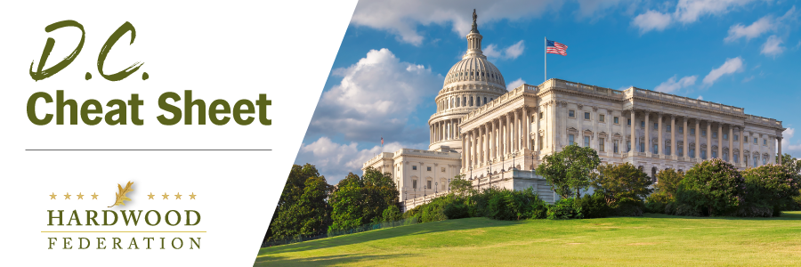

Quick Updates from Your HF Team

New House Speaker, New House Rules

Following several days of negotiations, Rep. Kevin McCarthy (R-CA) won enough votes on January 6 to secure the House Speakership as GOP members turned to a new rules package that will govern legislative procedures for the next two years. GOP lawmakers have placed a priority on dollars and cents, proposing that any bill that increases federal spending would be accompanied by equal spending cuts. Importantly for the hardwood sector, on the revenue side, the plan would require a three-fifths supermajority to increase taxes, including those imposed on small businesses. The Federation will keep you posted on the final make-up of the new rules package and how it will affect legislation impacting the industry.

House Farm Bill Leaders to Play Catch Up

In the wake of a protracted election for House Speaker, farm bill leaders, including Chair GT Thompson (R-PA) and panel member Rep. Dusty Johnson (R-SD) have stated that they have “catch-up” to do to move the legislation forward in 2023. Basic House-keeping matters such as final committee assignments and delays in hiring staff will prompt members to “burn the midnight oil,” according to Rep. Thompson. The extended debate over the Speakership also resulted in a postponed “listening session,” which Chair Thompson planned to lead in Harrisburg, PA, on Friday, January 6 and rescheduled for January 13.

EPA Proposes New Air Quality Regulations

On January 6, EPA announced proposed, new regulations on fine, air-borne particulate matter (PM 2.5) that may create more red tape for businesses, especially manufacturers, operating in areas of the country that the agency classifies as being in “non-attainment” of the standards. EPA identifies common sources of PM to include dirt roads, fields, fires and construction sites. Common “control measures” include requirements to spray dusty, outdoor areas to prevent tiny particles from becoming airborne. Manufacturers have criticized the proposal on the grounds that it will undermine business investment as the economy faces headwinds in 2023. The Federation will keep you posted on EPA actions that could increase costs for hardwood operations, especially as the agency moves forward with its agenda for the last two years of the current Administration.

