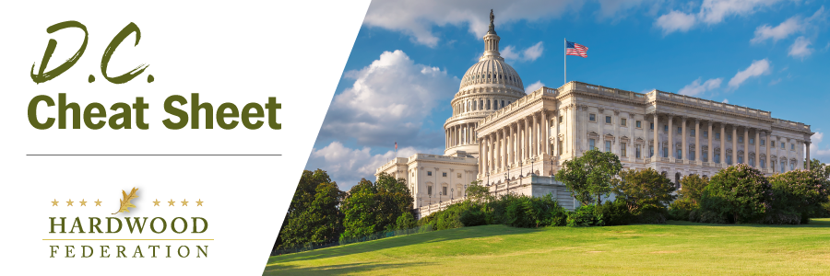
Quick Updates from Your HF Team

Industry Allies to Take Charge of House Ag and Natural Resources Panels

As previously reported, when the 118th Congress opens in January, the hardwood industry will have two strong allies in key House leadership roles, with Rep. GT Thompson (R-PA) set to assume the chair of the Agriculture Committee and Rep. Bruce Westerman (R-AR) heading up Natural Resources. In late November, the Federation proactively met with GT Thompson’s senior staff to discuss our key Farm Bill priority issues for 2023, including recognition of the carbon storage benefits of carbon (and the need for dollars to educate consumers, architects and designers of these facts), funding for international trade promotion programs, and incentives for low-carbon materials such as wood products. The industry also looks forward to continue a close partnership with ex-forester Westerman, an influential champion of active forest management, and will be meeting with his team in the near future to discuss priorities. As members of both committees are named, from both sides of the aisle, we will be scheduling similar meetings with their offices as well.

Coalition Urges Congress to Allow Business Interest Deduction Flexibility

On December 9, the Federation joined more than 200 industry allies in a letter urging congressional leaders to allow businesses to take full advantage of deductions for interest incurred on business loans. Sawmills and other capital-intensive operations rely on tax breaks directed at financing costs to raise capital, hire new workers, and grow. In recent months, higher interest rates have led to higher financing costs and are taking a bite out of revenues. Although the prospects for moving a tax package in December are slim, according to a senior Democrat on the Senate Finance Committee who spoke to the HF team on Monday, the next Congress could pick it up in 2023. .

Congress Moves Mass Timber Program with Defense Bill

As the countdown to the close of the 117th Congress approaches, lawmakers appear to be on track to adopt the National Defense Authorization Act (NDAA), which includes a mass timber program. The “must pass” defense bill, passed by the House last week, authorizes a pilot program to evaluate the use of timber in military construction projects, taking into account the role of wood products as a low-carbon construction solution. The Senate is expected to take up the bill this week or next.

NOTE TO OUR READERS: The "DC Cheat Sheet" will next publish on Thursday, January 5, 2023. The Federation team wishes you a Happy Holiday!

