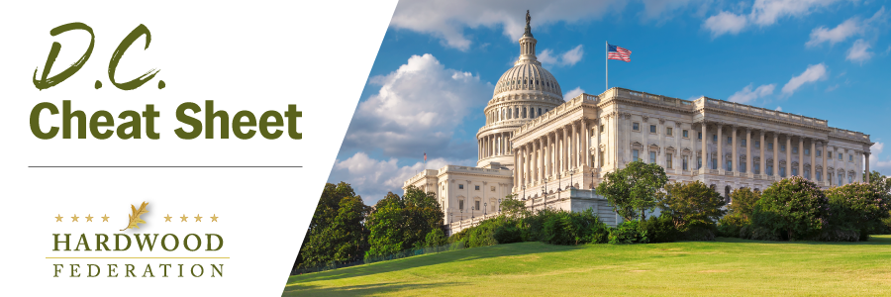

Quick Updates from Your HF Team
House Votes to Remove Rep. McCarthy as Speaker, Chaos Ensues
On the heels of having narrowly missed a government shutdown, on Tuesday, October 3, in a roll call vote, the House approved a measure 216 to 210 to remove Rep. McCarthy (R-CA) from the Speakership. Per the former Speaker's wishes, Rep. Patrick McHenry (R-NC) assumed the gavel as acting speaker and immediately adjourned the House until next week. Since that time, House Majority Leader Steve Scalise (R-LA) and Rep. Jim Jordan (R-OH) have thrown their hats in the ring to run for the House's top job. Unfortunately, most legislative business will be suspended until the election reaches a conclusion, a process that will begin next week.
Hardwood Industry, Allies Weigh in on White House Environmental Permit Proposal
On September 29, the Hardwood Federation joined the U.S. Chamber of Commerce and 24 allied groups in comments on the Administration’s proposed regulations to implement the National Environmental Policy Act (Act), an umbrella statute that outlines procedures for obtaining environmental permits. The coalition urges the Administration to revoke the proposal on the grounds that it is designed to lay out a permitting process that drives specific policy outcomes, such as mitigating climate change, rather than agency procedures, thereby exceeding the legal limits of NEPA. Industry also points out that the proposed changes would only add more delays to issuance of environmental permits, citing large scale bridge and port projects that took more than ten years to process, as opposed to two years in Canada and Australia for similar projects. The volume of comments submitted during the rulemaking could delay issuance of a final outcome into 2024.
Manufacturer Optimism Declines, According to Survey
In September, the National Association of Manufacturers (NAM) released a report showing that federal red tape, among other challenges, prevents expansion of manufacturing businesses in 2023. According to the survey, reflecting feedback from respondents in August, 69.1% of small manufacturers would hire more employees or give pay raises “if their regulatory burdens decreased.” Respondents identified workforce shortages (72.1%), expensive healthcare (60.7%) and supply chain disruptions (45.5%) as top challenges facing them at the close third quarter.

